**PRACTICAL 02**

Configure NP Server (NTPd), Install and configure NTPd, Configure NTP Client

(Ubuntu and Windows)

SETUP **NTP (Network Time Protocol)** SERVER:

Make sure your system is up to date before installing any packages.



The NTP service can be installed using the following command:



After installation, the NTP configuration file needs to be edited.



Comment all the pool server mentioned in the config

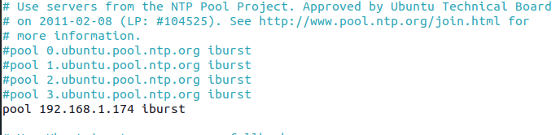

To configure the server to use its local clock, add the following line to the NTP configuration file /etc/ntp.conf:

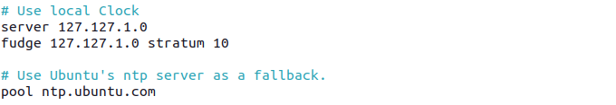

Explanation:

* server 127.127.1.0: This tells the NTP server to use its own local clock.
* fudge 127.127.1.0 stratum 10: This sets the stratum level to 10, indicating that the time is less accurate than a time source synced from a higher-level time server. This prevents clients from considering your local time server to be as accurate as a dedicated NTP server.

Restrict Access: To limit who can query or update your time server, configure the restrictions:

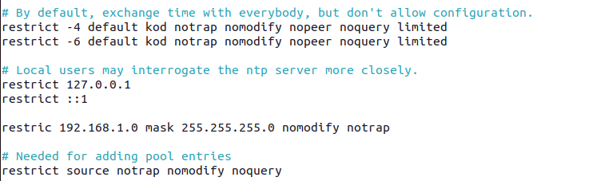

This configuration:

The restrict lines control which hosts or networks can access or modify your NTP server, and what kind of requests are allowed. These are security measures to prevent unauthorized modification or querying of your NTP server.

1. **restrict default kod nomodify notrap nopeer noquery**:
   * **default**: This applies to all IP addresses unless explicitly overridden by other restrict directives.
   * **kod**: Send "kiss-o'-death" packets to clients that violate rate limits.
   * **nomodify**: Prevent clients from modifying the server's configuration.
   * **notrap**: Prevent clients from setting traps (debugging mechanism).
   * **nopeer**: Disallow the server from establishing peer relationships (i.e., act as both server and client).
   * **noquery**: Prevent clients from querying the server for time or status.
2. 127.0.0.1 and ::1 allow local queries.
3. The last line allows devices in the 192.168.1.0/24 subnet to query the time but not modify it.

Allow NTP Broadcasting:

You can also configure the server to broadcast its time to other clients automatically using your your subnet’s broadcast address:

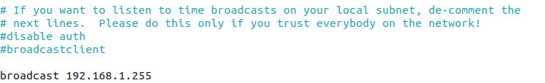

Restart the NTP server

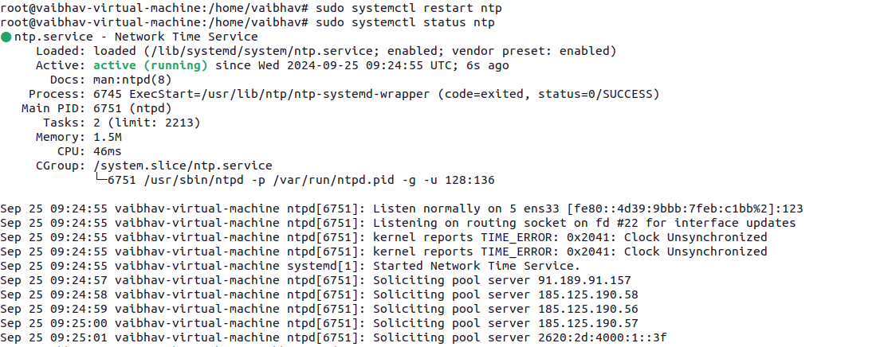

If you are running a firewall, you will need to open UDP port 123 for NTP.

For UFW (Ubuntu’s default firewall)



If it's set to UTC and you want to change it to your local time zone, use this command to change the time zone:



Verify that the local time reflects the correct time zone:

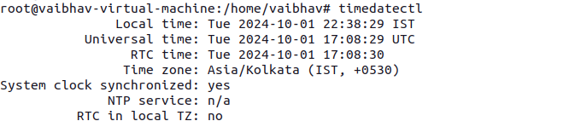

Sync Windows Clients to Local NTP Server:

Go to the Internet Time tab and click Change settings.

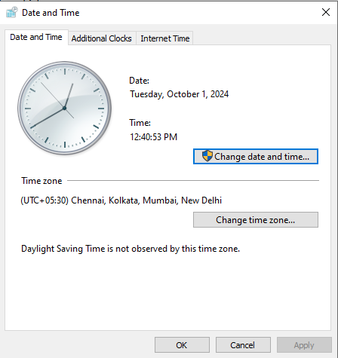

In the Server field, enter the IP address of your NTP server:

Click Update now to sync the time, then click OK.

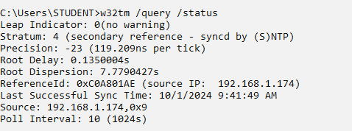

Sync linux Clients to Local NTP Server

On the client machines, configure them to use your NTP server by editing the /etc/ntp.conf file:



Check local time status

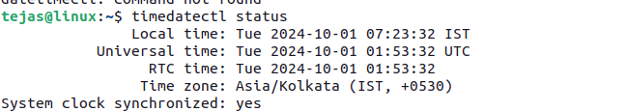

Restart the NTP service to apply the changes:

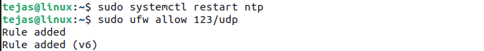

If it's set to UTC and you want to change it to your local time zone, use this command to change the time zone:



Check NTP synchronization:

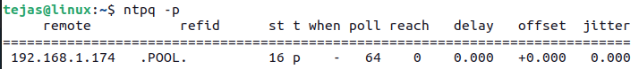

Remove package and its dependences command

